

SMART STAR EXAMINATIONS BOARD

**END OF TERM ONE EXAMINATION - 2024**

**PRIMARY THREE**

SOCIAL STUDIES WITH RELIGIOUS EDUCATION

***Time allowed : 2 hours 15 minutes***

Pupil's Name **…………………………………………………………………………………………………........................**

School Name**…………………………………………………………………………………………………………...............**

District Name**……………………………………………………………………………………………………….................**

|  |  |  |
| --- | --- | --- |
| **FOR EXAMINERS’ USE ONLY** | | |
| **QN. NO.** | **MARK** | **EXR`S NO.** |
| 1 - 10 |  |  |
| 11 - 20 |  |  |
| 21 - 30 |  |  |
| 31 – 40 |  |  |
| 41 – 43 |  |  |
| 44 – 46 |  |  |
| 47 – 49 |  |  |
| 50 – 52  53 - 55 |  |  |
| **TOTAL** |  |  |

**Read the following instructions carefully;**

1. This paper has **two** sections: **A** and **B**.

Section **A** has **40** questions and section **B** has **15** questions.

1. **All** the working for both sections **A** and **B** must be shown in the spaces provided.
2. All working must be done using a **blue** or **black** ball-point pen or fountain pen. Any work done in pencil other than graphs, pictures and diagrams will **not** be marked.
3. Unnecessary **changes** of work and any handwriting that cannot easily be read may lead to **loss of marks.**
4. Do **not** fill anything in the boxes indicated:

**“For Examiners’ Use Only”** and boxes inside the question paper.

©*2024 Smart Star Examinations Board*  ***Turn Over***

**SECTION A: 40 MARKS**

*Questions* ***1*** *to* ***40*** *carry* ***one mark*** *each*

1. Draw a picture of a table.
2. Mention **one** element of a good map

_______________________________________________________

1. Write **one** member of a nuclear family

____________________________________________________

1. Mention **one** example of a community. ______________________________________________________
2. Name the map symbol below

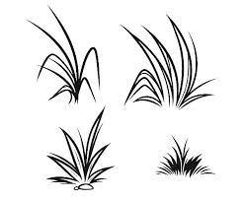

_______________________________________

1. Give **one** activity that brings people together

_______________________________________________________

1. 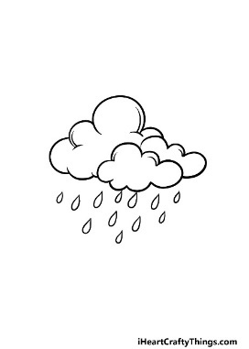Which state of weather is shown below

_____________________________

1. Write **BOU** in full.

______________________________________________________

1. Why do school children put on uniform**?**

_______________________________________________________

1. State **one** building material for a temporary house.

_______________________________________________________

1. State **one** bad habit among children at school.

_______________________________________________________

1. Point out any **one** leader at school.

_______________________________________________________

1. State **one** item used to clean the classroom

_______________________________________________________

1. Tick the road sign that helps people to cross a busy road.



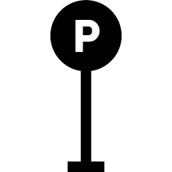

1. Name **one** physical feature that provides water to people. ______________________________________________________
2. In which direction does the sun rise**?**

_______________________________________________________

1. Mention any **one** means of road transport.

_______________________________________________________

1. Which school symbol directs people to our school**?**

_______________________________________________________

1. Why do people in your community rear donkeys**?**

_______________________________________________________

1. Draw and name **one** play material you know.

|  |
| --- |
|  |
| **Turn Over** |

1. Name the district where your school is found. ______________________________________________________
2. How are trees important in our school compound? ______________________________________________________
3. Write down any **one** duty of a child to his/her parents at home. ______________________________________________________
4. Write down **one** example of child abuse. _______________________________________________________
5. Mention **one** lake you know. _______________________________________________________
6. Write down your school motto. ______________________________________________________
7. Name the place where sick pupils go for treatment in a school.

______________________________________________

1. How is a fish monger important in our community? ______________________________________________________
2. 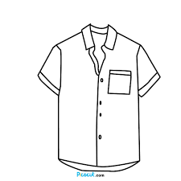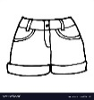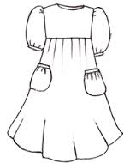 Name the basic needs of a family drawn.

________________________________________

1. Name the capital city of Uganda. ____________________________________________________
2. In which season do farmers plant their crops? ____________________________________________________
3. Mention **one** example of a recreation activity. _____________________________________________________
4. Why is a leopard called a wild animal? ______________________________________________________
5. Identify **one** tool used to keep peace and security. _______________________________________________________
6. Which type of fish is got from a swamp**?** _____________________________________________________

*For questions* ***36****-****40****, answer Either* ***Christianity*** *Or* ***Islam*** *But not* ***both*** *in a number.*

1. **Either:** Why do Christians pray? ______________________________________________________

**Or:** Why do Muslims pray? ______________________________________________________

1. **Either**: Name **one** custom in Christianity. _______________________________________________________

**Or**: State **one** custom in Islam. ________________________________________________________

1. **Either**: Mention any **one** religious leader in the church. _____________________________________________________

**Or**: Name the person who calls Muslims for prayers. ______________________________________________________

1. **Either**: Name the Christian symbol below.

____________________________________

**Or**: Name the Islamic symbol below.

___________________________________

1. **Either**: In which town was Jesus born**?** _______________________________________________________

**Or**: In which town was prophet Muhammad born**?** ______________________________________________________

**Turn Over**

**SECTION B: 60 MARKS**

Questions **41** to **55** carry four marks each

N

a

b

1. (a) Name the points of a compass marked:

a_________________________________

b_________________________________

(b) Write **one** group of people who use a compass in their work.

___________________________________________________

c) Write **N.E** in full ___________________________________________________

1. **Match people to their work**

Teacher makes furniture.

Doctor preaches the word of God/Allah.

Carpenter teaches children.

Priest treats sick people.

Teacher ____________________________________________

Doctor ______________________________________________

Carpenter ___________________________________________

Priest ________________________________________________

1. (a) Name the following symbols used on a map

________________________

______________________

______________________

(b) What is a map**? ______________________________________________________________________________________________________________**

1. (a) How useful are these animals to people
2. donkey_______________________________________
3. cat __________________________________________

(b) Write down any **two** wild animalsyou know.

(i) ________________________________________________

(ii) _______________________________________________

1. (a) **Match the types of transport to their means**

Road transport helicopter

Air transport ship

Water transport train

Railway transport bicycle

Road transport _________________________________

Air transport ____________________________________

Water transport ________________________________

Railway transport _______________________________

1. Write down any **two** products got from:
2. birds: _________________ ii) ________________________

(b) animals: _________________ii) _____________________

**Turn Over**

1. **Match correctly**

Lake Victoria known for salt mining.

River Nile known for crude oil mining.

Lake Katwe largest lake in Uganda.

Lake Albert longest river in Uganda.

Lake Victoria__________________________________________

River Nile______________________________________________

Lake Katwe ___________________________________________

Lake Albert ___________________________________________

1. (a) What do we call the violation of children’s rights? _______________________________________________________
2. Give **one** right of a child. ____________________________________________________
3. State any **two** basic needs of a child.
4. ___________________________________________
5. _________________________________________
6. (a) What is a community**?** _________________________________________________

b) Give **two** examples of communities you know.

1. ____________________________________
2. ____________________________________

c) Name **one** group of people found at school. ____________________________________________________

1. (a)Write any **two** building materials got from swamps.
2. _______________________________________________
3. _____________________________________________

(b) Name any **two** crops grown in swamps.

1. ___________________________________________
2. ___________________________________________

*For questions* ***51****-****54****, answer Either* ***Christianity*** *Or* ***Islam*** *but not* ***both*** *in a number*

1. **Either**:
2. Name the holy book for Christians. __________________________________________________
3. Write **one** Christian name for:
4. girls________________________________
5. boys ______________________________

**Or**:

1. Name the holy book for Moslems. __________________________________________________
2. Write **one** Moslem name for:

girls _____________________________

boys______________________________

1. **Either**:
2. On which day do most Christians go for prayers. _______________________________________________
3. How many apostles did Jesus have? _______________________________________________

1. Name **one** apostle of Jesus. ____________________________________________________

**Turn Over**

1. Draw this place of worship.

|  |
| --- |
|  |
| church |

**Or**:

1. On which day do Muslims go for Juma prayers? ___________________________________________________
2. How many times do Muslims pray in a day? _________________________________________________
3. Prophet Muhammad was born from _______________

(Kampala, mecca)

1. Draw this place of worship

|  |
| --- |
|  |
| mosque |

1. **Either**:
2. **Match the following correctly.**

Jesus grandfather of all believers.

Noah received the ten commandments.

Abraham died for mans sins.

Moses built an ark.

**Or**: **Match the following correctly.**

Adam grandfather of all believers

Ibrahim received the ten commandments.

Muhammad died for man’s sins

Musa built the ark.

1. **Either**:

(a)What do we call the fasting period for Christians? _____________________________________________________

(b) Give **one** thing a Christian should do during fasting. _______________________________________________________

(c)Give **two** reasons why Christians fast.

1. _______________________________________
2. _______________________________________

**Or**:

(a)What do we call the fasting month for Muslims? _____________________________________________________

(b) Give **one** thing a Muslim should do during fasting. _____________________________________________________

(c) State any **two** reasons why Muslims fast.

1. _________________________________________
2. _________________________________________
3. **For both**
4. Draw these needs of a family

|  |  |  |
| --- | --- | --- |
|  |  |  |
| water | food | clothes |

**Turn Over**

1. How do Christians/Muslims talk to God/Allah

_________________________________________________

1. Why do Christians/Muslims pray**?**

**________________________________________________**

***HAPPY HOLIDAYS***